How to cut the RAM for FUS camera
- first check whether the RAM is allocated to FUS camera . the below pic is correct to allocated (the solution way is only for 64bit and 16G RAM)
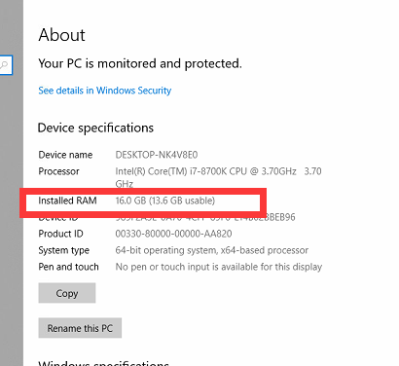
- Click Start button and input “CMD” and then right click run as administrator
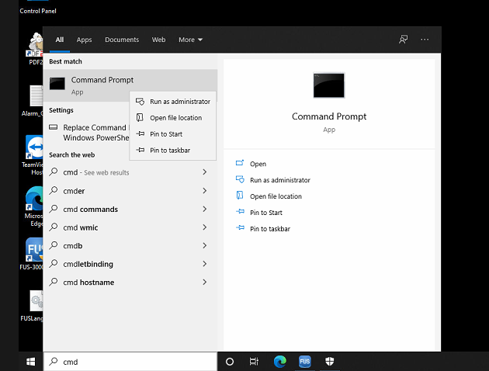
- Please copy this sentence as the below picture to the interface and click enter ,then it will show successfully (The sentence:bcdeditspacebar/setspacebar{current} spacebartruncatememoryspacebar0x3a0000000enter Notice the space bar)
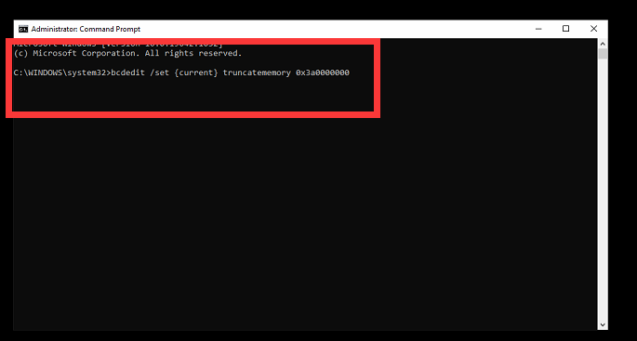
4.then restart the computer and analyzer

